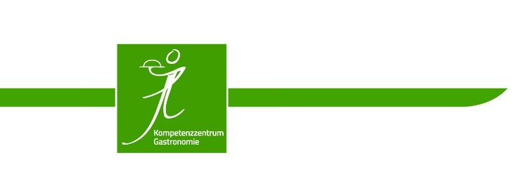

vocational school for assistants for hotel and tourism management

Bad Wörishofen/Germany
Außenstellenleiterin
Ute Mangrich, StDin
2022-03-08

Trainee Assessment

last name, first name of student | date of birth
Internship from: to:
internship company – please enter complete address and contact person

Mr/Ms _ _ was employed as a trainee in our company during the above-mentioned period.

The scope of duties consisted mainly of the following activities:

Details of the trainee‘s performance:
 | Expertise: He / She …
 |  | completed the tasks comprehensively and confidently. |  | completed the tasks above average. |  | completed the tasks as required. |  | completed the tasks.
 |  | handled all situations confidently and without difficulty. |  | worked independently. |  | generally worked independently. |  | showed uncertainties.
 | Quality of work: He / She …
 |  | always worked with utmost care and accuracy. |  | always worked carefully and accurately. |  | worked carefully and accurately. |  | generally worked carefully.
 | Commitment / Independence: He / She …
 |  | always showed initiative, great diligence and eagerness. |  | showed initiative and diligence. |  | always worked diligently. |  | worked according to instructions.
 |  | worked considerably more than could be expected. |  | worked more than could be expected. |  | performed tasks according to expectations. |  | generally worked according to expectations.
 | Comprehension: He / She …
 |  | constantly expanded knowledge with interest. |  | was interested in the tasks. |  | thought along with the work. |  | asked in case of problems.
 | Ability to work in a team: He / She …
 |  | was always extremely helpful. |  | was always helpful. |  | was helpful. |  | was generally helpful.
 |  | actively promoted cooperation. |  | supported the cooperation. |  | enjoyed working with others. |  | generally worked willingly with others.
Further remarks:

,

place, date signature of the internship company/ stamp

